Question 1
Recreate the following website using HTML
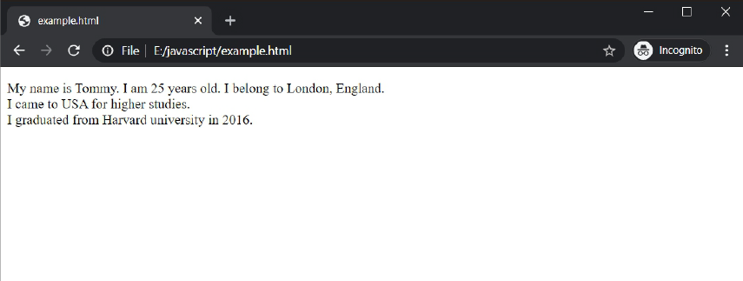

Question 2
Recreate the following website using HTML
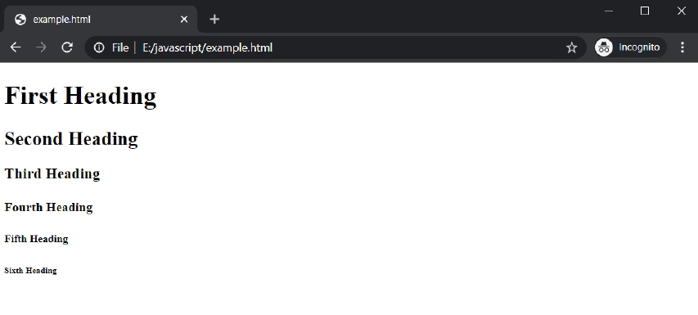

Question 3
HTML Formatting is a process of formatting text for better look and feel. HTML provides us ability to format text (without using CSS). There are many formatting tags in HTML. These tags are used to make text bold, italicized, or underlined etc. Using Visual studio and HTML elements from the websites provided in class, recreate the following web page:



